Ideation Phase
Brainstorm & Idea Prioritization Template
Date | 30 September 2026
Team ID | SWTID-2026-4970
Project Name | Import Data using Transform Maps  (Spreadsheet)
Maximum Marks | 4 Marks
Brainstorm & Idea Prioritization Template:
Brainstorming provides a free and open environment that encourages everyone within a team to participate in the creative thinking process that leads to problem solving. Prioritizing volume over value, out-of-the-box ideas are welcome and built upon, and all participants are encouraged to collaborate, helping each other develop a rich amount of creative solutions.
Use this template in your own brainstorming sessions so your team can unleash their imagination and start shaping concepts even if you’re not sitting in the same room. Reference: https://www.mural.co/templates/brainstorm-and-idea-prioritization
Group A – Data Loading  Load employee data from an Excel spreadsheet into an Import Set (staging) table using Load Data 2. Accept CSV / TSV files in addition to .xlsx  Schedule automatic imports from an external Data Source (JDBC / REST) | Group B – Mapping & Transformation  - Create a custom target table – Employee Test (u_employee_test) – with 5 employee fields  - Build a Transform Map and use Auto Map Matching Fields to map source to target  - Add transform scripts to clean data (trim spaces, fix case, standardise names)

Step-1: Team Gathering, Collaboration and Select the Problem Statement
Team gathering | The team came together to discuss how bulk employee data received as an Excel spreadsheet can be moved into the ServiceNow platform quickly and accurately.
Set the goal | Import structured employee data from a spreadsheet into ServiceNow using Import Sets and Transform Maps, avoid duplicate records, and report on the result.
Ground rules | Volume over value • No idea is a bad idea • Build on each other’s ideas • Stay focused on the problem statement.
Selected problem statement | PS-1: A ServiceNow administrator wants to import bulk employee data from Excel into ServiceNow, but manual entry is slow and re-importing the same file creates duplicates, because there is no staging, field mapping or unique-key (Coalesce) check – which makes them feel frustrated and worried about data accuracy.

Step-2: Brainstorm, Idea Listing and Grouping
Every team member wrote down ideas. Similar ideas were then grouped into four themes. Each numbered note below is one idea.
Group C – Data Integrity  - Enable Coalesce on Employee ID so repeat imports update records instead of duplicating  - Verify each load using Transform History  (inserts / updates / ignored / errors) and Import Log  - Enforce mandatory fields and validation rules before records are inserted | Group D – Reporting  - Create reports on the target table:  Employees by  Department (pie), Employees by Location (bar), Employee List  - Consolidate all reports on an “Employee Analytics Dashboard”  - Schedule reports and share them with HR and managers

Step-3: Idea Prioritization
Each idea was scored on Importance (value to the project goal) and Feasibility (how easily it can be built in ServiceNow) using a 1–5 scale, where 1 = low and 5 = high. Ideas in the top-right quadrant were selected.
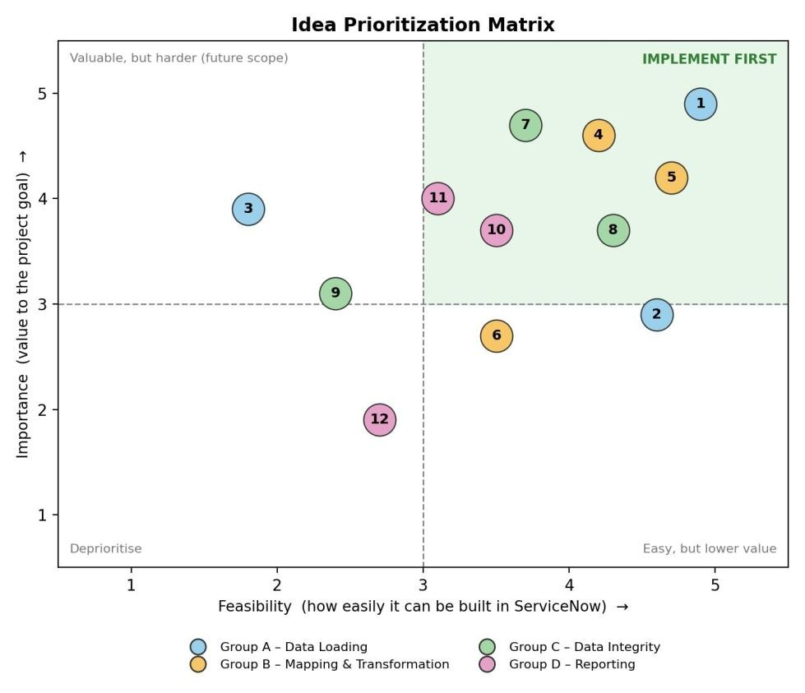
Dots are offset slightly so they do not overlap; exact scores are in the table below.
Idea Scoring and Decision:
# | Idea | Group | Importance | Feasibility | Decision
1 | Load Excel data into an Import Set using Load Data | A | 5 | 5 | Selected
2 | Accept CSV / TSV files | A | 3 | 5 | Future scope
3 | Scheduled imports from an external Data Source | A | 4 | 2 | Future scope
4 | Custom target table (u_employee_test) | B | 5 | 4 | Selected
5 | Transform Map with Auto Map Matching Fields | B | 4 | 5 | Selected
6 | Transform scripts to clean data | B | 3 | 4 | Future scope
7 | Coalesce on Employee ID (no duplicates) | C | 5 | 4 | Selected
8 | Verify loads with Transform History & Import Log | C | 4 | 4 | Selected
9 | Mandatory-field validation rules | C | 3 | 2 | Future scope
10 | Reports: by Department, by Location, Employee List | D | 4 | 4 | Selected
11 | Employee Analytics Dashboard | D | 4 | 3 | Selected
12 | Scheduled / shared reports | D | 2 | 3 | Future scope
Outcome: Ideas 1, 4, 5, 7, 8, 10 and 11 form the final solution – load the spreadsheet into an Import Set, map it with a Transform Map into a custom table, use Coalesce to prevent duplicates, verify the result in Transform History, and present it through reports on a dashboard. The remaining ideas are recorded as future enhancements.

